CPA COLLEGE OF ARTS & SCIENCE PUTHANATHANI – BIODIVERSITY CLUB 2019-2020
The biodiversity club mainly aims to equip younger generation (students) to create biodiversity awareness in community and the protection, preservation and management of natural resources. The club undertakes and support activities like nature camps, biodiversity awareness programs, initiatives and competition for students.
COORDINATOR
Priyanka T. (Dept. Of Botany)
STUDENT COORDINATOR
Muhammed Anshif ( 4th SEMESTER BOTANY)
MEMBERS
- Hasla Sherin 1st BA English
- Hisana Nasrin
- Namitha
- Naseeha
- Murshida
- Anshida
- Nafeema
- Shahala
- Anshifa
- Shaziya
- Sharmila
- Dilsha
- Aswathi A. P. 1st B. Com
- Najiya Mariyam K.
- Sinjitha
- Sreeshma
- Muhsina K. P.
- All students of 5th semester Botany
- All students of 3rd semester Botany
- All students of 3rd semester Zoology
- All students of 1st semester Botany
- All students of 1st semester Zoology

INAGURATION
Date: 22.08.2019
Venue: college auditorium
Supervising teachers: Asst. Prof. PRIYANKA T.
Asst. Prof. FLORA
Asst. Prof. SHIFA MAJEED

Biodiversity club was formally inaugurated by Prof. Abdul Riyas (Govt Arts & Science College, Kozhikkode) on 22nd August 2019 and was coordinated by Prof. Ahammed Basheer (Dept. of Zoology). Prof. Riyas gave an informative talk on the topic “Biodiversity”.He aware the previous and present conditions of biodiversity of the world, and also pointed the objectives to conserve biodiversity and natural resources.
There was a photography exhibition on the topic “Gods own country” - photos of Ajeeb Komachi were presented.

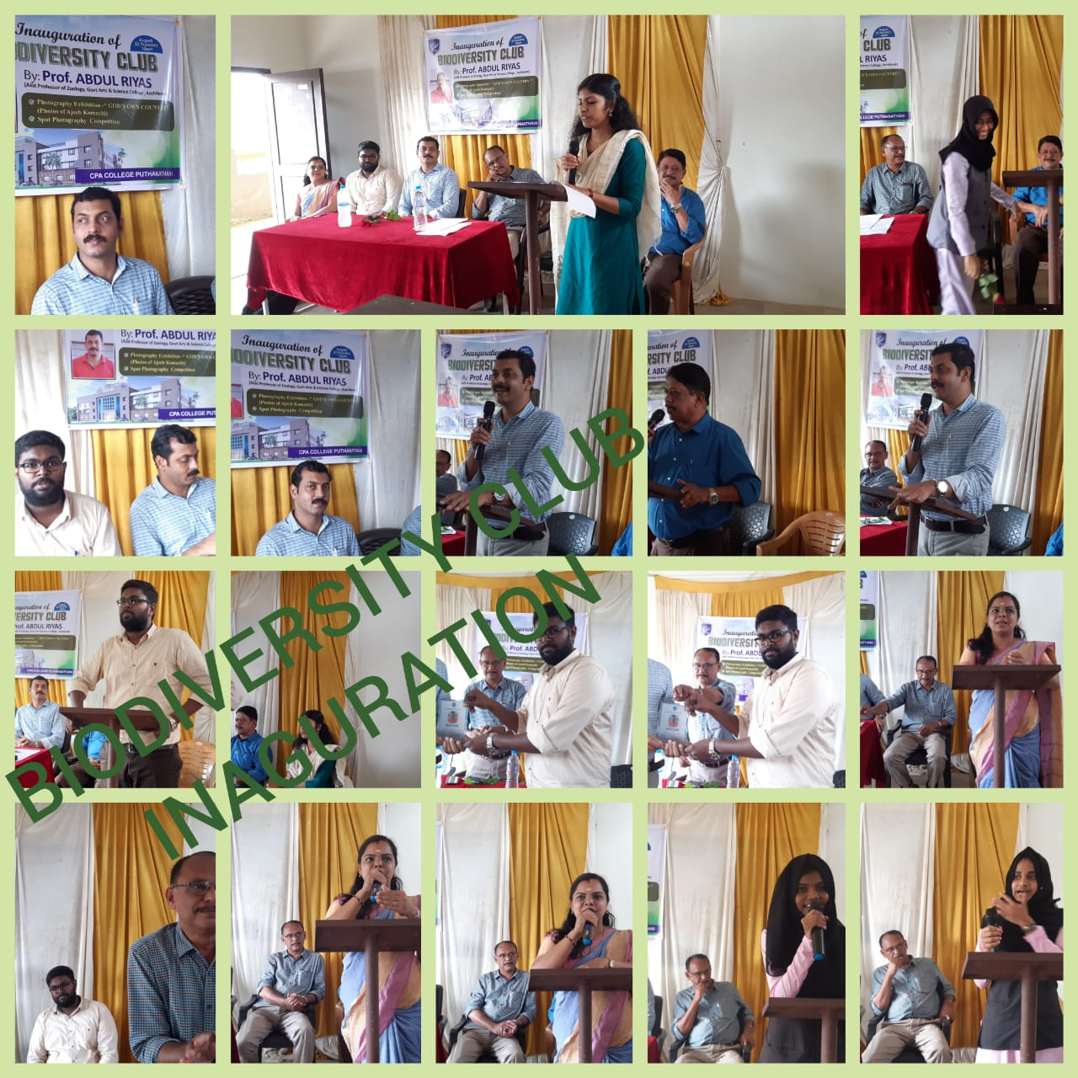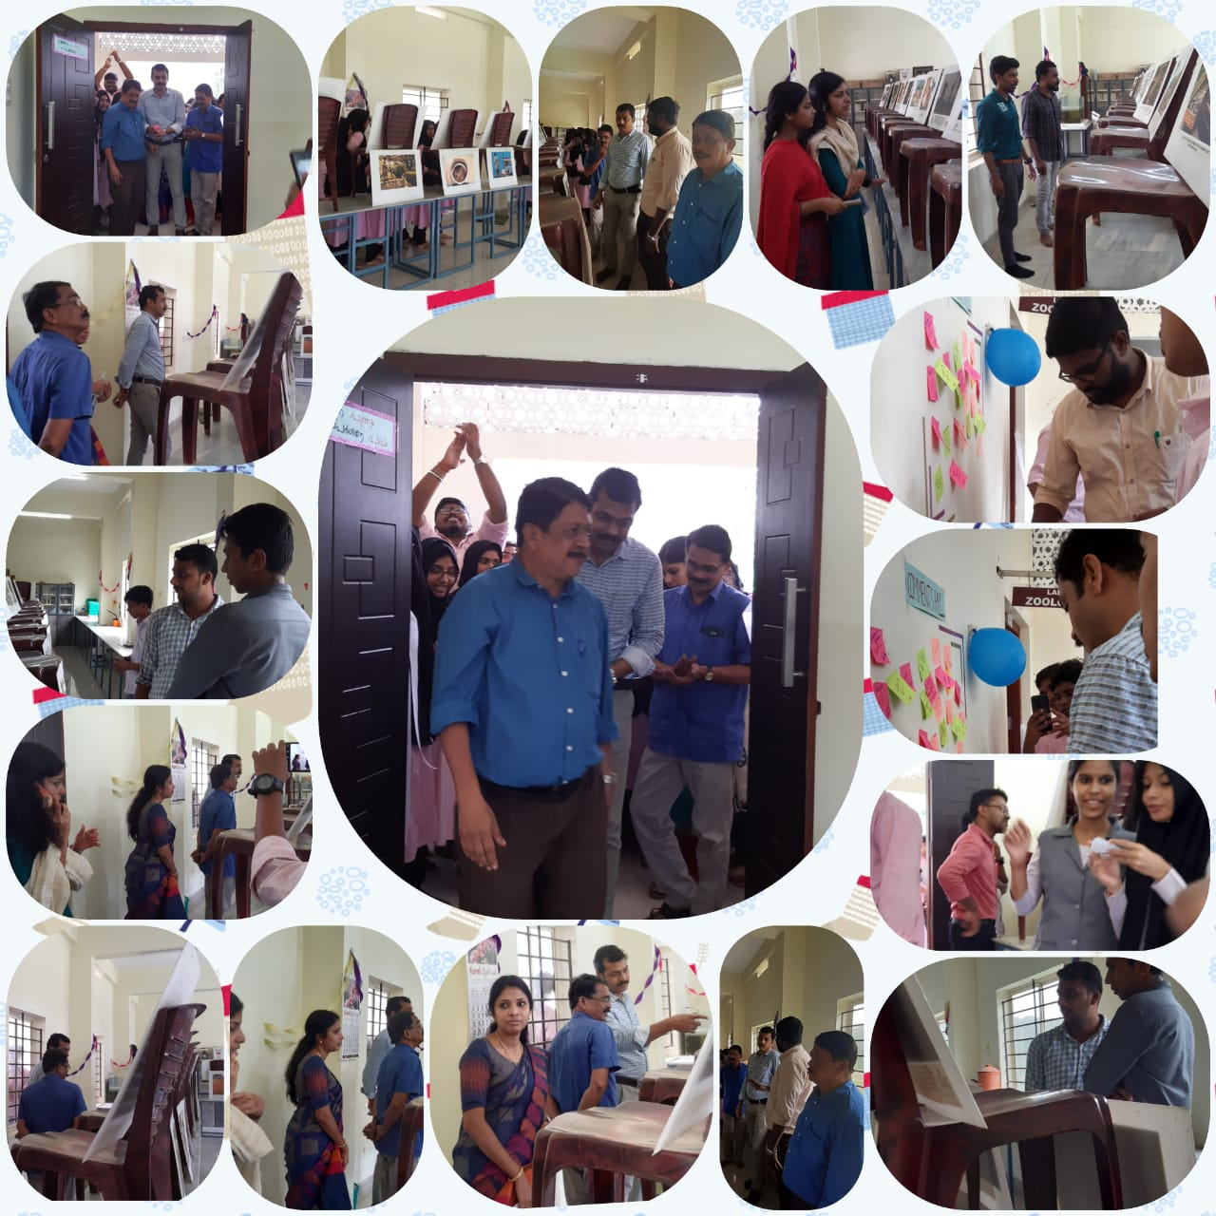

COMPETITION
- Foot note competition
Date: 22. 08.2019
Venue: Zoology lab

There was a foot note competition on a single photograph. Somany students and teachers also participated in it.
Winners:
- Shidhu Shaji (1st sem botany)
- Vaseem Siyad (1st sem B.com)
Asst. Prof. Subin (Dept. of Commerce)
- Shakir Shibili (3rd sem Zoology)
Noushin P.T. (2nd sem M.Com)

- Spot photography competition
Date: 25. 08.2019
Venue: College campus
Topic: ‘Nature and Love’
Winners:
- Safvan (5th sem BA ENGLISH)
- Vasudevan (3rd sem B.Sc ZOOLOGY)
- Jamsheer (3rd sem BBA)
Ashik T. P. (1st sem Bcom)
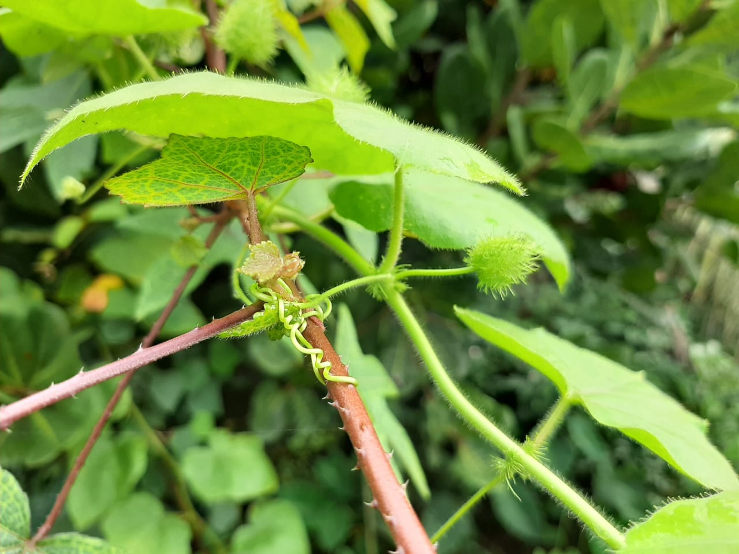

3.Intra college COLLAGE competition
Date: 18.12.2019
Venue: College Library
Topic: THE SMOULDERING INDIA
Winners:
- 1st BTTM
- 1ST BA ENGLISH
- 1ST B.Sc BOTANY

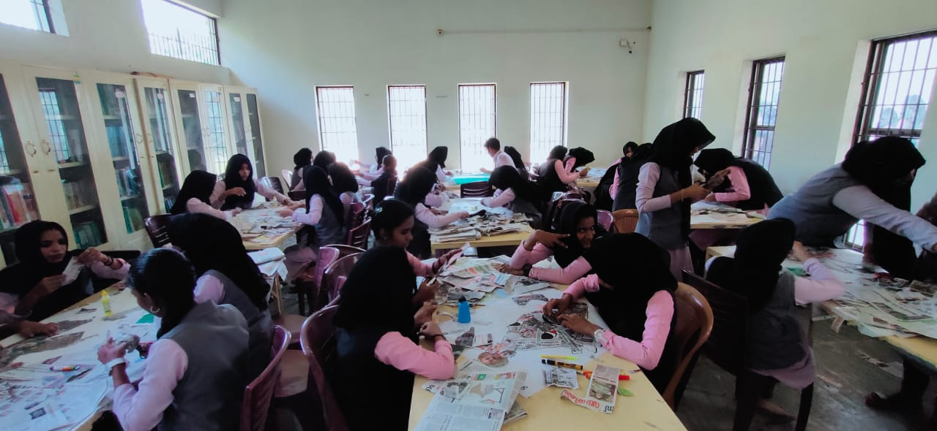

ONE DAY NATURE CAMP
Date: 03.02.2020
Venue : Silent Valley national Park, Palakkad
On 3rd February 2020 , we conducted a one day nature study programme to silent valley national park . Silent valley national park is one of the undisturbed South Western Ghats mountain rain forest and tropical moist evergreen forest in India. It was formerly known as Syrandrivanam. The national park has some rare flora and fauna. And our journey for exploring area was guided by the forest watchers and forest guard. The main attraction of the forest was lion tailed macaque, Indian Giant squirrel and different types of butterflies. The way to inside the forest was beautifully decorated by different types of butterflies. The buffer zone area of the forest was covered by 3 different group of tribals in 196 tribal colonies. We were visited the KSEB project area and the main source of kunthipuzha.
