HERITAGE CLUB
Heritage Education is not merely recreation for students but should be an important part of their learning process. It will help them understand history and society and will inculcate values of respect for diversity and tolerance. While it is important to highlight aspects of national heritage, it is also important to bring local heritages into the purview of heritage education programs. Very limited resources are required for the most basic heritage education programs. But most heritage activities, like heritage walks and heritage clubs can go a long way in helping the students to experience culture and heritage and bring alive many of the things they hear and see.
Aims
- To value and preserve the rich heritage of our Indian culture.
- To protect and improve the natural environment including forest, lakes, rivers, wild life and to have compassion for living creatures.
- To take pride in the unique diversity of India's cultural identity.
Objectives
-To understand who and what we are.
- To take pride in the unique diversity of India's cultural identity.
- To take care of the past as so to create a better future.
- To give an exciting dimension to learning

PROGRAMME 1
HERITAGE CLUB – INAUGURATION & QUIZ COMPETITION
The Heritage Club of CPA College of Global Studies. Puthanathani was held on 15th August 2020 at 10.30. The college Principal Dr. Hussain Randathani, inaugurated the club activities through Google Meet.
Club coordinator Ms. Deepa presented the major objectives of starting the club. The function started with a welcome speech of Ms. Sumayya, Assistant professor in English Department and the function was concluded with the vote of thanks by Ms. Asha,Assistant Professor in English Department.
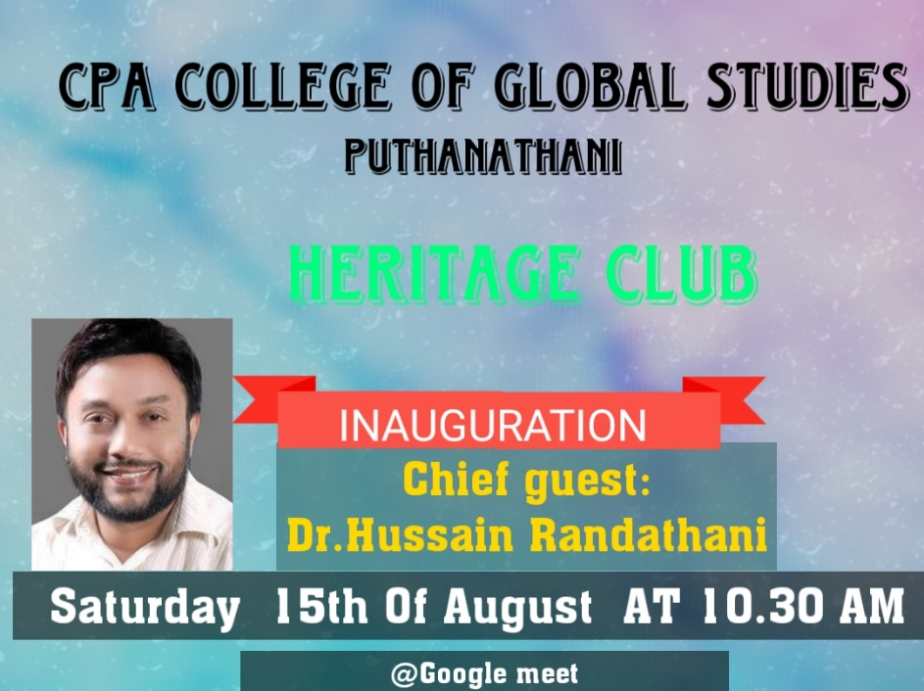

Activity – QUIZ COMPETITION
AIMS:
-To encourage students to look beyond their textual knowledge
-Ithelps the students to measure how much knowledge they have about India
Activity:
The Heritage Club conducted aquiz competition on Independence Day, after the formal session of inauguration,on 15.08 2020, in google form. Out of the seventy-four students participated, eight scored full marks.
OUTCOME :
- helps to improve or expand their knowledge of the specific area.
-Helps to build the students soft skills
-It helped to identify gaps in knowledge,build confidence and help students retain information.

PROGRAMME 2 – ONAM CELEBRATION
AIM :
-To maintain religious harmony
-To develop unity among students
-To make awareness on Kerala culture
Activity
CPA College of Global studies celebrated ‘AthijeevanathintePonnonam’ under Heritage Club on 27.08.2020at 11.00 am. through Google meet. College Principal Dr.HussainRandathani delivered Onam message. Annapoorna 3rd BSc delivered the welcome speech. Mr.Ubaid , Administrator of the college, Prof.Abdul Razak ,HOD of Commerce Department ,Muhammed Faris 3rd BSc and Risha 3rd BSc were felicitated the function. Sahad 3rd BSc gave the vote of thanks. The progremme was compared by ShanibaSherin, 5thBA .The entire college actively participated in the programme.
The celebration started with Onappatu and following Onapookkalam. Annapoorna 3rd BSc got first prize, Riduvan 3rd BBA got second prize and Pavithra 3rd BSc got third prize respectively for Onappattu. For Onapookkalam Varsha, 5th BA got first and Fathima Risla 5 BTTB got second respectively.

OUTCOME:
-It brought back student’s enthusiasm to perform on a specific thing that were lost due to the Corona Virus.
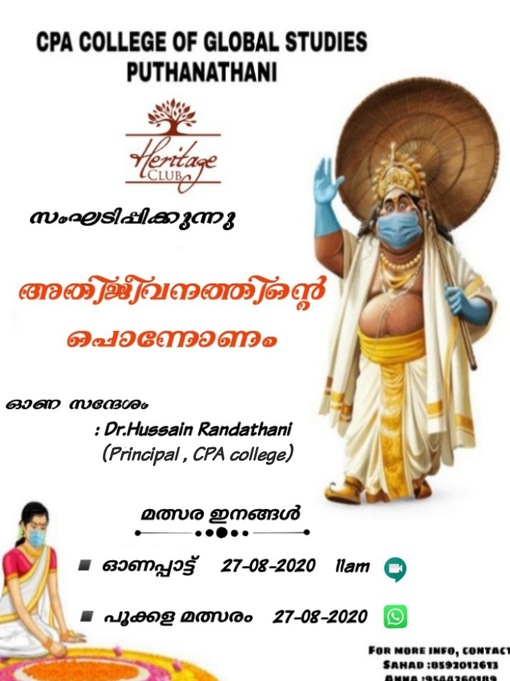

PROGRAMME 3
REPUBLIC DAY CELEBRATION &PATRIOTIC SONG COMPETITIONS
AIMS :
To keep the national consciousness among students
To develop team spirit among students
Activity
CPA College of Global Studies, Puthanathani celebrated Republic day on 26.01.2021 under Heritage club. NSS volunteers and the participants of patriotic song were participated the function. College principal Dr.HussainRandathani hoisted the flag. Welcome speech was delivered by Hasna Jasmin (1st BSC). MR. Riyas Raja (Circle Inspector of Police, Kalpakanchery) was the chief guest, who delivered the Republic day message. There was a ten minutes interactive session with the students. Mr. Sadarudheen (Vice principal), Mr. Ubaid Anandavur (College Administrator), Ziya Ul Haque (1st BSC) and Shabith Ali (NSS Coordinator) felicitated the function. Shehma (1st BSC) delivered vote of thanks. After the session, Inter Department patriotic song was held at the Update hall. Among the six teams, Department of BSC, Finance and BTTM bagged 1st ,2nd and 3rd prize.
OUTCOME :
The student were able to develop a good team spirit among themselves.

