

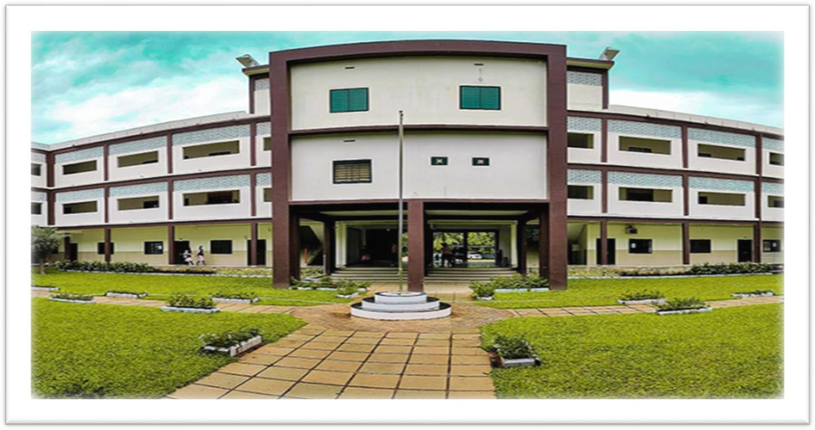

PROGRAMME REPORT

BEING WELL-BEING KNOW YOUR MIND AND BODY WOMEN DEVELOPMENT CELL

INDEX

Sl. No | Content | Page Number
1 | Programme Request
2 | Programme Approval
3 | Circular/Notice
4 | Poster
5 | Programme Schedule
6 | Faculty Profile of Resource Person
7 | Participants List
8 | Programme Report
9 | G tagged photo and one normal photo
10 | Feedback Forms & Analysis

PROGRAMME REPORT

Title of the Programme: Being Well Being: Know your Mind and Body
Date: 05/08/2025
Name of the Co-Ordinator: LAMEES VP
Objective of the Programme: Mental and physical health awareness class.
Name of the Resource Person: Anju Gafoor, Psychologist

The Women's Development successfully conducted a program titled “Being Well Being: Know your Mind and Body” on August 5, 2025. The session, aimed to promote well-being and mindfulness among students, and featured a talk by Ms. Anju Gafoor, a psychologist and representative of Bodhini, a convoy for Mindful Living (NGO). The programme began with a welcome address by Shibila of Final BA English, highlighting the importance of mental well-being and mindfulness in today’s fast-paced world. College Principal Sir John Joseph inaugurated the programme by introducing the role of mindfulness in promoting mental well-being.
Ms. Anju Gafoor delivered a thought-provoking talk on the importance of self-awareness, self-care and mindfulness in achieving overall well-being. The speaker shared practical tips and strategies for managing stress, anxiety and other mental health challenges. The session was interactive, where students participated enthusiastically and shared their thoughts and experiences.
Students appreciated the speaker’s expertise and the interactive nature of the programme. The student co-ordinator of WDC, Lisana of BA English, delivered the thanks note expressing gratitude to the speaker, students and the organisers for making the programme a success.

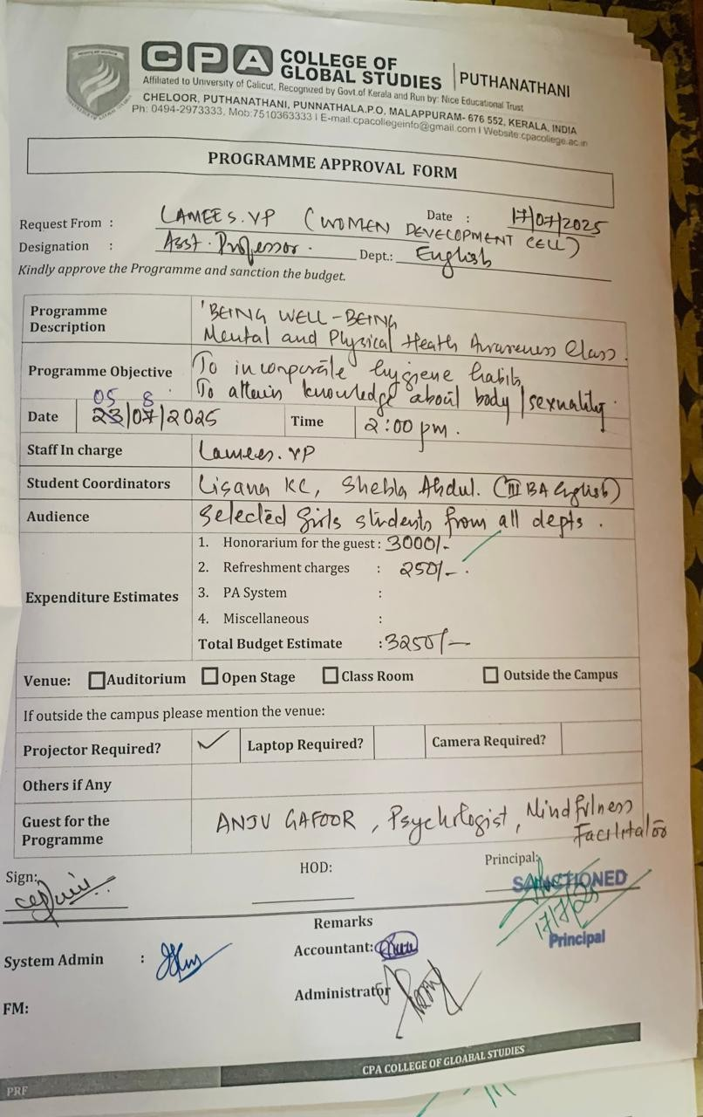

01/08/2025

NOTICE

WOMEN DEVELOPMENT CELL CPA COLLEGE OF GLOBAL STUDIES

This is to inform you that an interactive session on the topic “Mind and Body” will be conducted by the Women Development Cell on August 5, 2025, at Update Hall from 2 pm to 4 pm.

Organised By: WOMEN DEVELOPMENT CELL DATE: 05/08/2025
TIME:2 PM-4 PM VENUE: UPDATE HALL
GUEST SPEAKER: ANJU GAFOOR (Psychologist, Mindfulness Facilitator)

Lamees VP
WDC COORDINATOR

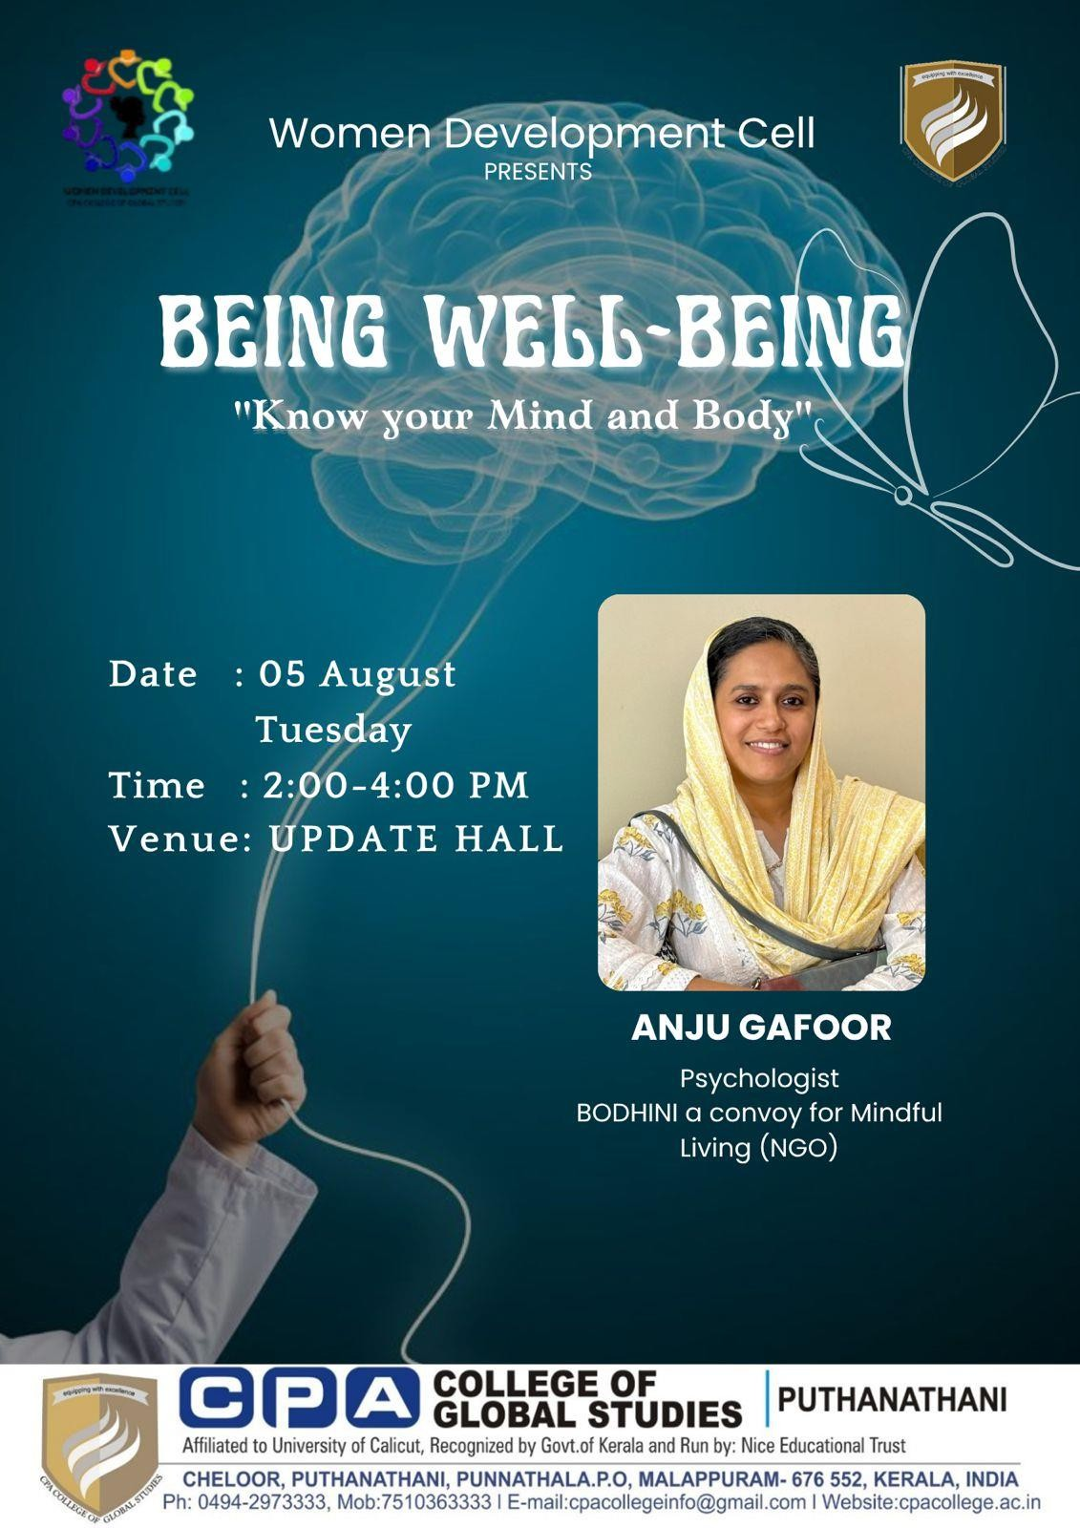

CPA COLLEGE OF GLOBAL STUDIES WOMEN DEVELOPMENT CELL BEING WELL BEING
KNOW YOUR MIND AND BODY ON
5TH AUGUST 2025 TUESDAY
2:00 PM -4:00 PM PROGRAMME SCHEDULE

- Welcome Speech: Shibila K (III BA English) (3mts)

- Inaugural Address: John Joseph. Principal, CPA College(10mts)

- Session Held: Anju Gafoor, Psychologist “BODHINI”

- Vote of Thanks: Hamda (III BTTM) (5mts)

